MORNING WORSHIP SERVICE
Nov 15, 2015

Opening Song “I Saw the Light”

Opening Prayer/Announcements

Worship Hymns “He Keeps Me Singing” 425
“It Is Well With My Soul” 410
“What A Day That Will Be”
“Lord Be Glorified” 457
“Glorify Thy Name” 249

Offering/Offertory

Special Music

Message Bro. David Atwood
Invitation “Have Thine Own Way, Lord” 294
.

Closing Prayer

Evening Service at 6:00

Living Proof Live
March 4-5, 2016 (Fri & Sat)
Waco, TX: Extraco Event Center
Contact Patti Radford if you might be interested in attending

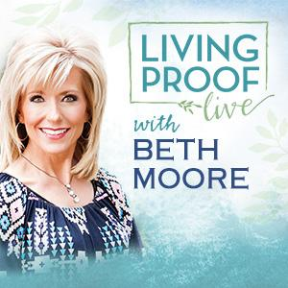
NURSERY – available for children age 0 to Kindergarten
Paula Knobloch

Hostesses for November Ushers for November
Shirley Marecle, Judie Coffey, Joe Daniel, Mickey Stanford,
Judy Broussard, Otisann McManus David Condron, Hugo Breithaupt

Immediate Need Prayer List
Prayer & Request Information

(Please complete name & address information on reverse side)

I would like to speak with the Pastor.

I would like more information on this church.

I have Prayer Requests or Needs

Date:

Permission to Publicize:
Church Bulletin Yes No
Email Prayer Chain Yes No

Prayer Request:

Prayer For
Name
Address
Phone

Given By
Name
Address
Phone
Please Contact By

Card Phone Visit

Comments

Pray Bobby and Judie Coffey as Bobby continues to recover.

Pray for Twyla Hughes, Theresa Bartlett’s grandmother, as she has health issues

Pray for Helen Emery. She has a broken tail bone.

K s b c

Keeping His Word through Sunday School, Bible Study and Church Attendance/Worship

Sunday School Bible Studies for November:

Nov 1st Stand Courageously Daniel 3:13-18,26-28 Nov 8th Live Humbly Daniel 4:28-35 Nov 15th Confront Sin Daniel 5:17-28 Nov 22nd Act Faithfully Daniel 6:6-10,13-16,19-22 Nov 29th When Opposition Strikes Acts 4:23-31

9:45 a.m. each Sunday – A place for everyone

WE’D LOVE FOR YOU TO JOIN US!

